Any questions contact us:Newjerseyexpos@gmail.com
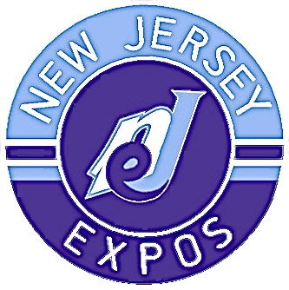

White Package: $250, Sponsor receives white package plus your business logo and link will be added to the expo’s website
Blue Package: $500, Sponsor receives blue package plus will be added to our social media pages and receive shout-outs on expos videos
Purple Package $1,000 + Sponsor receives purple package plus expos merchandise

Name of business or individual:

Phone: Email:

Sponsor Package (check one): White Blue Purple

Your Website:

Please email this form & your business logo to newjerseyexpos@gmail.com
Payment: once we have your form, we will send an invoice with payment link to the email listed.

THANK YOU FOR YOUR SUPPORT

