Any questions contact us: Newjerseyexpos@gmail.com
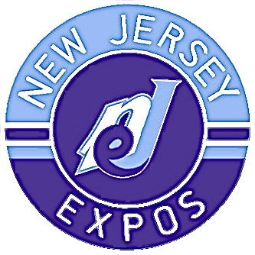

White Package: $250 Sponsor receives their business logo with a link added to the expos website
Blue Package: $500 Sponsor receives white package plus will be added to our social media pages and shout-outs on expos videos
Purple Package: $1,000 + Sponsor receives blue package plus expos merchandise
In a time when things are getting more expensive, we are looking to find sponsors to help cover the cost of league fees, tournaments, and equipment. We never want a kid to stop playing because of costs. We are doing as much as possible to cover these costs but need your help.

Name of business or individual:

Phone: Email:

Sponsor Package (check one): White Blue Purple

Website:

Please email this form & your business logo to newjerseyexpos@gmail.com
Payment: once we have your form, we will send an invoice with payment link to the email listed.

THANK YOU FOR YOUR SUPPORT

